**GARBAGE MONITORING USING ARDUINO**

A project report

submitted as part of the internal evaluation process for the course

15ENV300 ENVIRONMENTAL SCIENCE AND SUSTAINABILITY

by

1. **KISHORE G (AM.EN.U4ECE16127)**
2. **YOGESH KUMAR M.P (AM.EN.U4ECE16163)**
3. **ATHUL SURIYAKIRON (AM.EN.U4ECE18501)**
4. **GREESHMANTH .K (AM.EN.U4ECE16125)**



**DEPARTMENT OF MECHANICAL ENGINEERING**

**AMRITA VISHWA VIDYAPEETHAM**

**AMRITAPURI CAMPUS (INDIA)**

**December 2018**

**DEPARTMENT OF MECHANICAL ENGINEERING**

**AMRITA VISHWA VIDYAPEETHAM**

**AMRITAPURI CAMPUS**



**BONAFIDE CERTIFICATE**

This is to certify that the project report entitled “**Garbage Monitoring Using Arduino**”submitted by **Kishore G (AM.EN.U4ECE16127)**, **Yogeshkumar M.P (AM.EN.U4ECE16163)**, **Athul Suriyakiron(AM.EN.U4ECE18501)**, **Greeshmanth (AM.EN.U4ECE16125)** as part of the internal evaluation process for the course **15ENV300 Environmental Science and Sustainability** is a Bonafide record of the work carried out by them under the guidance and supervision of me at the Department of Mechanical Engineering, Amrita School of Engineering, Amrita Vishwa Vidyapeetham, Amritapuri Campus.

**Mr. Gevargis M Thomas**

Faculty Associate,

Department of Mechanical Engineering,

Amrita School of Engineering,

Amritapuri

**DEPARTMENT OF MECHANICAL ENGINEERING**

**AMRITA VISHWA VIDYAPEETHAM**

**AMRITAPURI CAMPUS**

**DECLARATION**

We, **Kishore G(AM.EN.U4ECE16127)**,**Yogeshkumar M.P(AM.EN.U4ECE16163)**, **Athul Suriyakiron(AM.EN.U4ECE18501)**, **Greeshmanth (AM.EN.U4ECE16125)** hereby declare that this project report entitled “**Garbage Monitoring Using Arduino**”is the record of the original work done by us under the guidance of **Mr. Gevargis M Thomas**, Faculty Associate, Department of Mechanical Engineering, Amrita School of Engineering, Amritapuri.

Place: Amritapuri

Date: 11-10-2019

**Kishore G (AM.EN.U4ECE16127)**

**Yogesh Kumar M.P (AM.EN.U4ECE16163)**

**Athul Suriyakiron(AM.EN.U4ECE18501)**

**Greeshmanth K (AM.EN.U4ECE16125)**

**Acknowledgment**

Foremost, we would like to thank Amrita University for giving us this wonderful opportunity and for supporting our every need within their infrastructure and we are thankful for our project guide Mr. Gevargis M Thomas for introducing us to this project and by guiding and reviewing our work thoroughly and supporting us throughout the whole project and finally we would like to thank our counselor Mrs. Anuraj and our adviser Mrs. Poorna for their love and support throughout this project.

**Kishore G (AM.EN.U4ECE16127)**

**Yogesh Kumar M.P (AM.EN.U4ECE16163)**

**Athul Suriyakiron(AM.EN.U4ECE18501)**

**Greeshmanth K(AM.EN.U4ECE16125)**

**Contents**

**Title Pages**

Chapter 1

**Introduction** …

Chapter 2

**Aim, scope and objective of the study** …

Chapter 3

**Materials and methods** …

Chapter 4

**Results and discussion** …

Chapter 5

**Conclusion** …

Chapter 6

**References** …

**Chapter 1**

**INTRODUCTION**

* 1. **Introduction**

Introduction

Around the world, waste generation rates are rising. In 2016, the worlds’ cities generated 2.01 billion tons of solid waste, amounting to a footprint of 0.74 kilograms per person per day. With rapid population growth and urbanization, annual waste generation is expected to increase by 70% from 2016’s level to 3.40 billion tons in 2050. This stunning amount of waste is partly because 99 percent of the stuff we buy is trashed within 6 months. The amount of garbage human beings throws away is rising fast and won't come down this century without transformational changes in how we use and reuse materials.

In the earlier report, worldbank.org warned that global solid waste generation was on pace to increase 70 percent by 2025, rising from more than 3.5 million tons per day in 2010 to more than 6 million tons per day by 2025. The waste from cities alone is already enough to fill a line of trash trucks 5,000 kilometers long every day.

The environment has a limited capacity for waste assimilation, therefore, this assimilative capacity of the environment may be exceeded or put under too much stress to handle the large quantity of waste and this may result in pollution and resource degradation. As a result of managing the waste, we will decrease their effects on our health, our surroundings, and the environment. Thousands of lives are lost every year to environmental-related diseases such as cholera, diarrhea, malaria fever, typhoid fever, river blindness and so on. It is generally recognized that there is a strong relationship between the effective management of solid wastes and good quality of life and a healthy environment. The attractiveness of the country to foreign visitors and investments is very much influenced by a clean and healthy environment. Without an efficient method of trash collection, at its worst, the growing public is exposed to the breeding ground of bacteria, insects, and vermin due to accumulated trash, which also promotes the spread of air and water-borne diseases. And at a minimum, it is a public nuisance and eyesore especially for those metropolitan areas that are heavily dependent on tourism to generate revenues to municipals service.

Managing waste properly is essential for building sustainable and livable cities, but it remains a challenge for many developing countries and cities. Effective waste management is expensive, often comprising 20%–50% of municipal budgets. Operating this essential municipal service requires integrated systems that are efficient, sustainable, and socially supported.

We are advancing in diverse fields of science and technology and hence it’s no surprise that the Internet of Things (IoT) and other technologies are entering the waste and recycling industry. From providing simpler solutions for route optimization and operational analytics to reduce costs, companies across the globe are getting creative when it comes to using technology to better manage waste and recycling. Waste collection is an essential city service. Ample opportunity exists worldwide for smart technology to increase efficiency and improve the quality of waste collection services.

A dramatic increase in the production of waste reflects unprecedented global levels of economic activity. The increase in the waste stream can be attributed to several factors: rising levels of affluence; cheaper consumer products; the advent of built-in obsolescence and shorter product life cycles; the proliferation of packaging; changing patterns of taste and consumption; and the demand for convenience products.

Today, solid waste segregation is the biggest challenge faced by urban areas and metropolitan cities across the world. Especially, in a country like India which has weak environmental regulations, the situation is becoming worse.

Technology has transformed the way waste management works with automated sensors that trigger instant alerts every time a container is full and needs service. Currently, most municipal waste collection operations focus on emptying containers according to predefined schedules. This is inevitably inefficient, with half-full bins being emptied, poor use of city assets and unnecessary fleet fuel consumption.

Bin level sensors along with real-time fill-level information collected through monitoring platforms substantially reduce the overflow of garbage by informing operators of such instances before they occur. It provides users the capability of knowing the fill-level of each waste container in real-time so that they can take data-driven actions ahead of time. Along with a live monitoring platform, waste collection staff can plan how collections are implemented, targeting only the locations of full trash bins.

Ultrasonic bin level sensors offer the means to have fewer trucks on the road for less time, which means less fuel consumption and less greenhouse gas emissions. Fewer trucks cluttering up the roads also means less noise, less air pollution, and less road wear.

As a part of the internal evaluation process for the course **15ENV300 Environmental Science and Sustainability,** we have implemented an Arduino based garbage monitoring project. It is distinctly interesting, if not actually amusing that we have achieved an uncomplicated and straightforward concept of waste management through our project. An impressively successful methodology to identify bin levels and authority notification were integrated into this project. Technology has become an integral part of our daily life and technical research advancements continue in the field of waste management. This project may be at a nascent stage of such advancements, but this could become a rudiment integral in economic waste management with its elementary engineering design and implementation.

For the introduction, we briefly describe our project as,

**“A microcontroller system integrated with ultrasonic sensors which will identify the level of trash in a smart bin when the trash crosses the threshold limit, it immediately notifies the concerned entity or individual to empty the trash.”**

We have creatively used our Engineering background for a social cause, but an idea will just remain as an idea until it is implemented. There lies the disadvantage of educating and convincing the need for waste management. We can speculate about the psychological, educational and social origins of the above-mentioned disadvantage, but the bottom line is, this is one of the most fundamental, widespread and pernicious dilemmas plaguing our society today. Recognizing this problem can unlock the idea bottleneck and generate actual innovation and improved solutions for the environmental degradation caused by human beings.

**Organization of the report**

The report is organized as follows:

Chapter I - Introduction

Chapter II – Aim, scope, and objectives of the study

Chapter III – Materials and methods

Chapter IV – Results and discussion

Chapter V – Conclusion

Chapter VI – References

**Chapter 2**

**AIM, SCOPE & OBJECTIVE OF STUDY**

**2.1 AIM**

This project aims to efficiently handle solid waste through modern technology in an economical and ergonomic manner and also to send emergency fire alert to prevent rapid fire spread.

**2.2 Scope**

The scope of this project lies in commencing a timely ordered configuration to dispose of solid waste in a city or household. The evidence is mounting that poor traditional methodology used in waste management with very little technology has little cause and effect. It is of utmost importance and priority that we engage an efficient methodology to handle household waste which is increasing at a mercurial level with a higher population.

Putting the current trends of production and consumption together and considering the consequences they will have for waste management, new challenges are emerging, and the current situation must be seen in a different way. Our waste management systems and our market conditions, even at their best, are incapable of handling the growing amounts of waste globally. So, unless a new paradigm of global cooperation and governance is adopted, a tsunami of uncontrolled dumpsites will be the prevailing waste management method, especially in Asia. In 2016, 5% of global emissions were generated from solid waste management, excluding transportation.

Household waste makes up over 80% of MSW for some countries, particularly those of the OECD (Organization for Economic Co-operation and Development) countries. Then, there is a need to achieve environmental sustainability and win over community participation to sort their waste at the source. The human population continues to grow which greatly impacts the world around us, our actions can and often do have dramatic and long-lasting consequences. Human beings are just one of the estimated 8.7 million species on earth which generates trashes which earth cannot recycle or reuse and hence the sole destructor of our earth. Consumerism, overproduction, and advertisements to manipulate consumer spending are all intertwined with the massive generation of waste. Consumer spending is explicitly connected with economic development and hence any decline in consumer spending will affect the economy which enforces us to implement stringent actions for waste management.

What is the future of municipal solid waste management, especially for developing countries? Is there a way to sustainably process MSW faster than we generate it? Could the cost of MSW management be reduced to a point to encourage the growth of the markets of value-added products from waste products such as biogas, compost, recycled materials? There are no definite solutions for each of the problems mentioned above, however, there are small scale solutions that can conform by and large a significant part of the problem to an extent, as suggested in this project.

Implementation is the process that turns strategies and plans into actions in order to accomplish strategic objectives and goals. Hence an effective implementation of such smart trash bins can advance an efficient strategy for solid waste management. Here are the most common reasons why the implementation of strategies for waste management fail and our project solutions for each problem:

* **Lack of ownership:** The most common reason a plan fails is a lack of ownership. If people don’t have a stake and responsibility in the plan, it’ll be business as usual for all but a frustrated few. **Solution:** Warnings and red alerts with the fine amount for bins which are not emptied within 5 hours of the notification
* **Lack of communication:** The plan doesn’t get communicated to the authorized individual and they don’t understand how they contribute. **Solution:** If the primary receiver did not respond in the first hour then it should notify secondary receivers.
* **Getting mired in the day-to-day:** People consumed by daily responsibilities, lose sight of long-term goals. **Solution:** Engage robots or other electronic gadgets to empty smart bins.
* **Out of the ordinary:** The plan is treated as something separate and removed from the management process. **Solution:** Introduce incentives for proper waste management using smart bins.
* **An overwhelming plan:** The goals and actions generated in the strategic planning session are too numerous because the team failed to make tough choices to eliminate non-critical actions. People don’t know where to begin. **Solution:** Implement short term and long-term goals to intricate discipline into managing waste efficiently.
* **A meaningless plan:** The vision, mission, and value statements are viewed as fluff and not supported by actions or don’t have people buy-in. **Solution:** Educating people about the need for proper waste management strategies. Introducingcomplementary discounts and offers for implementing such strategies will add value to such plans.
* **No progress report:** There’s no method to track progress, and the plan only measures what’s easy, not what’s important. No one feels any forward momentum. **Solution:** track citizen contribution in implementing greener eco-friendly values by using smart bins or other methodologies. Recognize and reward citizens for their contribution.
* **No accountability:** Accountability and high visibility help drive change. This means that each measure, objective, data source, and initiative must have an owner. **Solution:** Software-based real-time accountability
* **Lack of empowerment:** Although accountability may provide strong motivation for improving performance, employees must also have the authority, responsibility, and tools necessary to impact relevant measures. Otherwise, they may resist involvement and ownership. **Solution:** The government should encourage citizens to use technology for waste management.

Solutions presented along with the problems are the major scope for the implementation of such a project.

**2.3 Objective of the study**

While this is a topic that people are aware of, waste generation is increasing at an alarming rate. Countries are rapidly developing without adequate systems in place to manage the changing waste composition of citizens. A 2018 worldbank.org report projects that rapid urbanization, population growth, and economic development will push global waste to increase by 70% over the next 30 years – to a staggering 3.40 billion tons of waste generated annually. The fastest-growing regions are Sub-Saharan Africa and South Asia, where total waste generation is expected to triple than double by 2050, respectively, making up 35% of the world’s waste. The Middle East and North Africa region are also expected to double waste generation by 2050.

We are advancing in almost all the diversification of human inventions but there lies a lot of questions towards the existence and objectives of the human species. The major concern is whether human beings exist for destruction or protection of earth? We have more weapons than trees, we have more buildings than forests, we have more consumption than our returns for nature. Since solid waste tops the list of waste generated, we preferred to work on the same. We define our primary objective of the study as - “finding a simple but contemporary solution for managing solid waste at its source”.

**Chapter 3**

**MATERIALS AND METHODS**

**3.1 Materials Required**

As our goal is to implement a very efficient and cost-effective, yet highly reliable garbage monitoring system the following instruments or tools have been utilized to ensure that it's user-friendly and functional:

1. Trash Can
2. Male to Male Wire
3. Node MCU ESP8266 Arduino
4. US-100 Ultrasonic sensor
5. Scotch Mounting Tape Double-Sided

**Material Description:**

**3.1.1 Trash Can**

This is a device, or a container used for the storage of discarded materials which is also known as waste materials that one has no further use for in order to discard them as in a whole

**3.1.2 Female to Female Wire Connectors**

* Female to Female AWG 26 Solderless Ribbon Jumper Wires for Breadboard Prototyping
* 40 x 10cm (~4 Inches) and 40 x 20cm (~8 Inches) for 80 Total Wires
* Color-Coded with 10 Colors and 4 Wires of the Same Color in Each Length
* Insulated Wire Casing with 2.54 mm Pitch DuPont-Compatible Connectors
* For Use in Development and Prototyping with Arduino, Raspberry Pi, Single Board Computers, LoveRPi Kits, and more

**3.1.3 Node MCU ESP8266 Arduino**

NodeMCU is an open-source firmware and development kit that helps you to prototype or build IoT products. It includes firmware which runs on the ESP8266 Wi-Fi SoC from Espressif Systems, and hardware which is based on the ESP-12 module. The firmware uses the Lua scripting language. It is based on the eLua project and built on the Espressif Non-OS SDK for ESP8266.

**MCU Definition:**

MCU stands for Microcontroller Unit - which really means it is a computer on a single chip. A microcontroller contains one or more CPUs (processor cores) along with memory and programmable input/output peripherals. They are used to automate automobile engine control, implantable medical devices, remote controls, office machines, appliances, power tools, toys, etc.

**Power:**

Power to the NodeMCU v3 is supplied via the on-board USB Micro B connector or directly via the “VIN” pin. The power source is selected automatically.

The device can operate on an external supply of 6 to 20 volts. If using more than 12V, the voltage regulator may overheat and damage the device. The recommended range is 7 to 12 volts.

**3.1.4 US-100 Ultrasonic sensor**

The Ultrasonic sensor module is a convenient way of measuring distances from objects. This module has a lot of applications such as parking sensors, obstacle, and terrain monitoring systems, industrial distance measurements, etc. It has stable performance and high accuracy ranging from 2cm to 450cm. The module sends an ultrasonic signal, eight pulses of 40kHz square wave from the transmitter; the echo is then picked up by the receiver and outputs a waveform with a time period proportional to the distance. The connected microcontroller accepts the signal and performs necessary processing.

**US-100 Ultrasonic sensor**

The US-100 Ultrasonic Distance Sensor Module operates from a wide voltage range and provides both digital and serial data output modes. The US-100 features accurate temperature corrected range detection. It can output the distance in millimeters using a serial data output mode. Alternatively, the distance can be calculated by measuring the amount of time that a digital output is held high.

**Power:**

This sensor can be used with both 3.3V and 5V microcontrollers and only consumes 2mA when idle.

**3.1.5 Scotch Mounting Tape Double-Sided**

Scotch Heavy Duty Mounting Tape makes it so easy to beautify and organize your space quickly and easily. Whether you're creating a gallery wall or affixing the family chore chart, this permanent double-sided foam tape delivers a strong bond every time. Your work is up and ready to admire in 30 seconds flat–no nails or hammer needed. Never let how you're going to hang it get in the way of your creativity with the powerful adhesion of Scotch Indoor Mounting Tape.

**3.2 Methodology**

Methodology is the systematic, theoretical analysis of the methods applied to a field of study. It comprises the theoretical analysis of the body of methods and principles associated with a branch of knowledge. Typically, it encompasses concepts such as paradigm, theoretical model, phases and quantitative or qualitative techniques.

In this project the methodology used are as follows:

**3.2.1 Ultrasonic Sensor**

An Ultrasonic sensor is a device that can measure the distance to an object by using sound waves. It measures distance by sending out a sound wave at a specific frequency and listening for that sound wave to bounce back. Ultrasonic sensors are based on the measurement of the properties of acoustic waves with frequencies above the human audible range, often at roughly 40 kHz. They typically operate by generating a high-frequency pulse of sound and then receiving and evaluating the properties of the echo pulse.

1. **Connection:**

This module is connected to NodeMCU and waits for the NodeMCU reply. When it gets a reply from NodeMCU, it sends the signal and waits for receiving that signal and calculates that amount of time and gives it to NodeMCU.

1. **Usability:**

US-100 Ultrasonic sensor used to detect the level of garbage in dustbins. This shows real-time results on our web page through other hardware connections.

**3.2.2 NodeMCU**

The ESP8266 chip requires 3.3V power supply voltage. It should not be powered with 5 volts like other Arduino boards. Node MCU ESP-12E dev board can be connected to 5Vusing micro USB connector or VIN pin available on board. The I/O pins of ESP8266 communicate or input/output max 3.3V only i.e. the pins are NOT 5V tolerant inputs.

1. **Connection:**

Connected to a power supply of 3.3v

1. **Usability:**

This esp826612e is being used for the purpose of connecting the ultrasonic sensor with a web application through the WI-FI module esp8266. This sensor is placed on the board at which the ultrasonic sensor and esp8266 are connected.

**The Node MCU is connected to US-100 as follows:**

**NODEMCU US-100**

**VCC -> 3.3V**

**GND -> GND**

**D1 -> ECHO**

**D2 -> TRIG**

Here the ultrasonic sensor has 5 pins and in which we are using only 4 since we only need one for ground in both US-100 and Node MCU esp8266. the VCC of NODEMCU is connected to the 3.3V pin using a female to female connector and then we use 2 GPIO pin that is general purpose input output pin as we have only 2 main function to measure which is the distance and temperature, here the first GPIO pin D1 is connected to the ECHO pin of the US-100 for getting the distance input and then the next GPIO pin D2 is connected to the TRIG pin of US-100 for measuring the temperature and finally we have a ground pin both NODE MCU and US-100 which is named as GND and we connect them both again using a female to female connector. Once connecting the circuit as above-mentioned we move on to the coding part of the microcontroller and US-100

**3.3.3 Programming the Microcontroller**

The Node MCU is connected to a laptop using a micro USB cable and coded using Arduino IDE

1. **This part of the code is for defining and identifying Distance:**

**{**

if((mmDist > 1) && (mmDist < 10000))

{

Serial.print("Distance: ");

Serial.print(mmDist, DEC);

if(mmDist>30)

{ Serial.print("TRASH IS EMPTY");

digitalWrite(LED_BUILTIN, HIGH);

delay(1000); }

else {

Serial.print("TRASH IS FULL ");

digitalWrite(LED_BUILTIN, LOW);

delay(2000);

}

}

**Block-A Algorithm Theorized:**

In this block of code we are using a particular algorithm for making the ultrasonic sensor US-100 to calculate the distance between the trash and the lid of trash bin, in order to do this we are using a variable called “mmDist” in which we store the calculated distance which is not static and keeps on updating once the microcontroller is active or powered up and this process is repeated even after we get the desired output i.e., “trash is full”. and for showing this process we are using a line of code called “Serial.print("TRASH IS FULL ");” and in order to visually notify a distant user we are using a NodeMCU which has built in led which can be coded and make it active or glow once the trash is full and to make the led glow we are using this line of code “digitalWrite(LED_BUILTIN, HIGH);”and the word “HIGH” implies that the led should glow. and we are setting up a threshold for any sized trash can for that we are using “ if(mmDist>30)” this line of code where mmDist contains the value of measured distance and 30mm is the threshold in which the Node MCU determines whether the trash is full or empty i.e., when mmDist is greater than 30mm the trash is assumed to be full and for all the other cases where mmDist is less than 30mm then the trash is assumed to be full and then “digitalWrite(LED_BUILTIN, HIGH);” this line of code is executed. once this is executed the inbuilt LED starts to glow thus notifying the user or viewer the trash can full and can't be filled any further. once this block of code is executed then the next block which will define the temperature to identify fire and send a fire alert is being executed.

1. **This part of the code is for defining temperature and identifying fire:**

temp = US100Serial.read();

if((temp > 1) && (temp <200)) // temperature is in range

{

temp -= 45; // correct 45º offset

Serial.print("Temp: ");

Serial.print(temp, DEC);

if(temp>100)

{

Serial.print("Fire Alert");

digitalWrite(LED_BUILTIN, HIGH);

delay(1000); }

else

{

digitalWrite(LED_BUILTIN, LOW);

delay(2000);

}

}

}

**Block B Algorithm Theorized:**

In this block of code we are using a particular algorithm for making the ultrasonic sensor US-100 to calculate the temperature between the trash and the lid of trash bin, in order to do this we are using a variable called “Temp” in which we store the measured temperature which is not static and keeps on updating once the microcontroller is active or powered up and this process is repeated even after we get the desired output i.e., “Fite Alert”. and for showing this process we are using a line of code called “Serial.print("Fire Alert ");” and in order to visually notify a distant user we are using a NodeMCU which has built-in led which can be coded and make it active or glow once the fire is detected and to make the led glow we are using this line of code “digitalWrite(LED_BUILTIN, HIGH);”and the word “HIGH” implies that the led should glow. and we are setting up a threshold for any sized trash can for that we are using “if((temp > 1) && (temp <200))” this line of code where temp contains the value of measured temperature and we check the temperature between 1 degree Celsius and 200 degree Celsius and the threshold in which the Node MCU determines whether the trash is on fire is by when temp is greater than 100 degree Celsius then the trash is assumed to be on fire and for all the other cases where mmDist is less than 100 degrees Celsius then the trash is assumed to be not on fire and then “digitalWrite(LED_BUILTIN, HIGH);” this line of code is executed. once this is executed the inbuilt LED starts to glow thus notifying the user or viewer the trash is on fire or not. once this block of code is executed then again, the A block which will define the distance to identify the distance between the trash and lid and sends an alert once it's full.

thus, both this block of code is repeatedly executed N number of times until the power supply of 3.3v is given.

**3.3.4 Fixing the materials**

Using Scotch Mounting Tape Double-Sided we fix the Node MCU in the trash canfor safety measures we fix this system on the bottom of the trash lid in order to prevent contact with trash to avoid system failure

**Chapter 4**

**RESULT AND DISCUSSION**

**The hardware connection setup for the system.**

An ESP8266 12E board is connected to the US-100 Ultrasonic Sensor via digital input/output pins. The Ultrasonic sensor is attached with a dustbin and detects the garbage in the dustbin. The ESP8266 Wi-Fi Module takes the data from the Ultrasonic sensor and send the data to the server for web application and show the garbage data in real-time results.

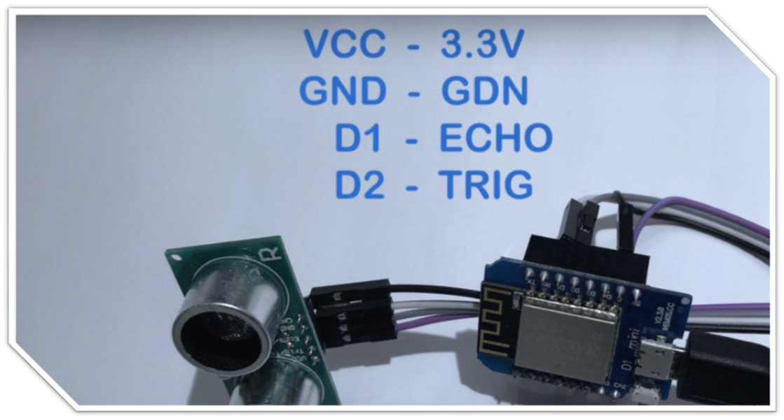

**Test1:**

The first test conducted in a situation where the garbage bin is empty. As shown in **fig1** when Dustbin is empty - 0 % and Ultrasonic sensor show the output to the dustbin.

**Test2:**

In the second test conducted in the situation where the garbage Full level in the dustbin. As shown in **fig2** Dustbin when Full garbage - 80 to 100 % and the Ultrasonic sensor show the output to dustbin.

**Fig1: Test 1**

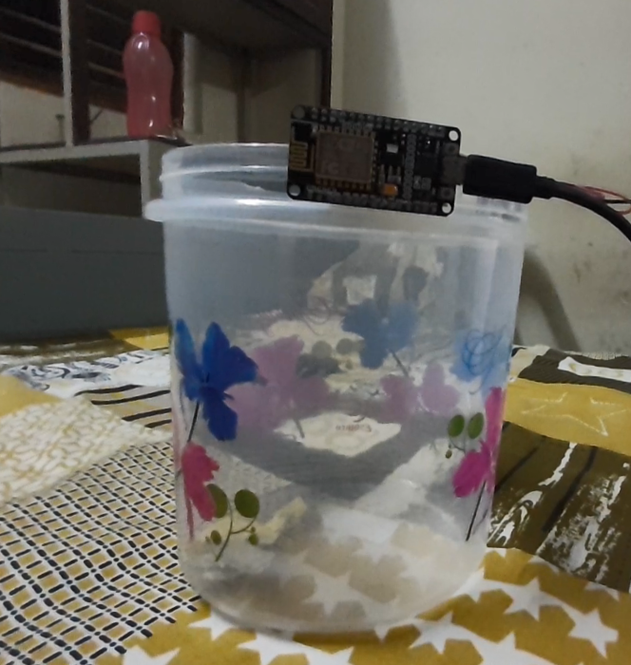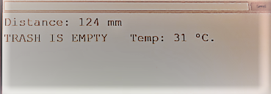

**Fig2: Test 2**

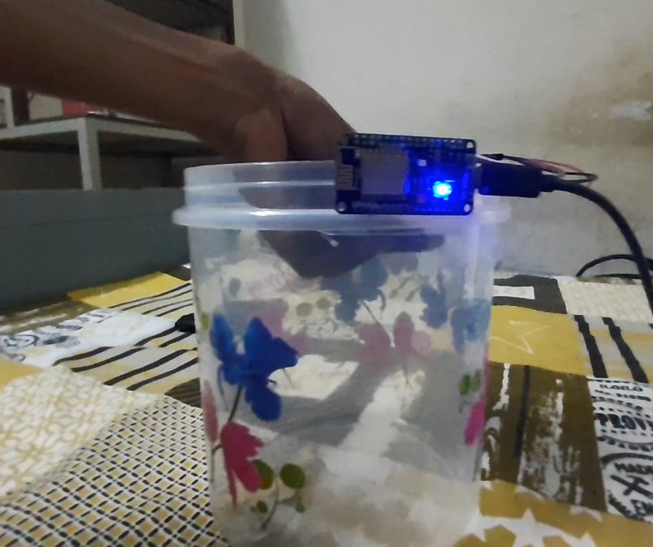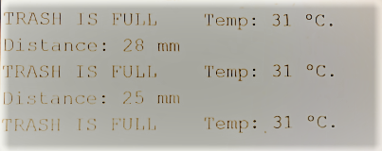

**Chapter 5**

**CONCLUSION**

**Conclusion**

We set out to experiment a prevailing concept of waste management using sensors, but in an economical and ergonomic design. As part of the same we had used a container which serves as a trash bin an Arduino board as a microcontroller and Ultrasonic sensor to measure the distance. We had challenges in the design and implementation process, but we managed to redesign the whole project successfully. The project endorses the tagline of Swachh Bharat Abhiyan-” One step towards cleanliness”. Throughout this project we have progressively studied in detail the need of such a system for efficient waste management and hence have come to a conclusion that waste management has a significant role in waste disposal. This system proposes an efficient waste management methodology to keep our environment clean and ensures hygienic surroundings. Improper disposal and improper maintenance of domestic garbage create issues in public health and environmental pollution. This project attempts to provide a practical solution to help the local municipal administrator in the garbage management system i.e. monitoring of domestic garbage clearance at the proper time to avoid damage to public health. However, we would also bring to the attention of the reader that the design may be outdated when you are reading this report, due to the rapid inventions in science and technology. Hence, we would appreciate your efforts to understand the sincere interest and work we have done over time to build this design. We would also suggest the reader to go through upcoming smart trash management methodologies implemented in developed countries and their future works with the advancement of Artificial intelligence and IOT for waste management. In conclusion the project executes a contemporary solution for waste management at an economic and ergonomic perspective. We can extend this system and can be merged into different smart systems. Technology demand “To be smart” possible only if we adopt intelligent systems for our needs.

**Chapter 6**

**FUTURE WORK**

**Future work:**

The development team, after complementing the development of the project, they set some aims and goals to achieve in the future, which is known as future plan. This part includes all the expected modifications and changes in the project which are to be done in the future according to the feedback given by users

**Future plans are as follows:**

• Use of shortest path algorithm to provide route optimization.

• Directions from the current location towards the smart bin.

• Integration with smart cities.

• Adding location sharing feature in social media.

• More features into a mobile application.

• Services to different waste management organizations through our application.

**Chapter 7**

**REFERENCE**

**Reference:**

[**[1**]](https://www.researchgate.net/publication/313252675_Smart_Garbage_Monitoring_System_for_Waste_Management) Smart_Garbage_Monitoring_System_for_Waste_Management

[[2]](https://ieeexplore.ieee.org/document/8299814) Petrol_Level Indicator_with_Automated_Audio_Alert_System

[[3]](https://www.researchgate.net/publication/330428120_Garbage_Monitoring_System_Using_Internet_of_Things_Methods_and_Protocols) Garbage_Monitoring_System_Using_Internet_of_Things_Methods_and_Protocols

[[4]](https://www.researchgate.net/publication/332779949_IOT_Based_Waste_Management_System_with_Metering_for_Smart_Village_Project_Application)IOT_Based_Waste_Management_System_with_Metering_for_Smart_Village_Project_Application

[[5]](https://www.researchgate.net/publication/332564972_IoT_Based_Smart_Trash_Bins_-A_Step_Toward_Smart_City) IoT_Based_Smart_Trash_Bins_–_A_Step_Toward_Smart_City

[[6]](https://www.researchgate.net/publication/331676073_Intelligent_System_for_Garbage_collection_IoT_technology_with_Ultrasonic_sensor_and_Arduino_Mega)Intelligent_System_for_Garbage_collection_IoT_with_Ultrasonic_sensor_and_Arduino_Meg

[[7]](https://www.researchgate.net/publication/333687640_Smart_Dustbins_for_Smart_Cities) Smart_Dustbins_for_Smart_Cities